**LANDING PAGE:**

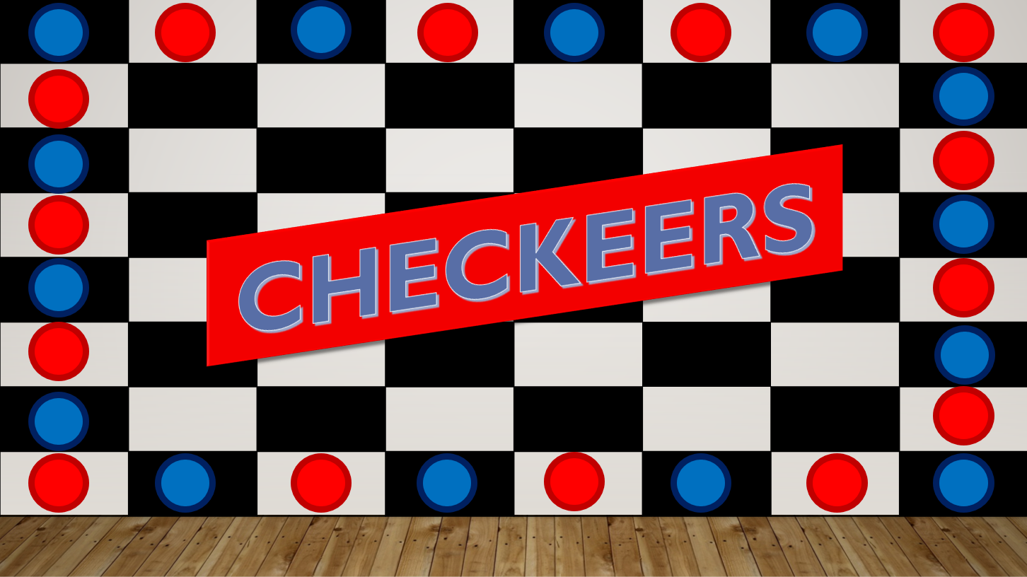

**HOME PAGE:**

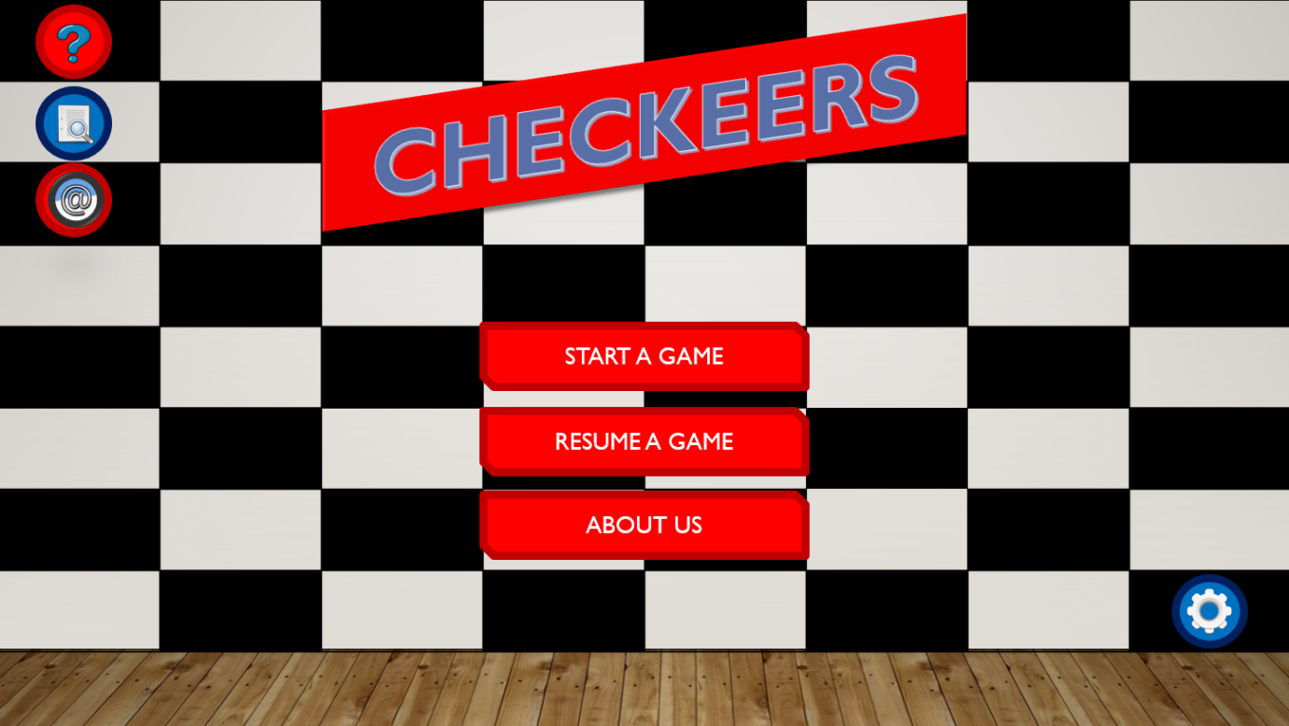

**Pointing on a button:**

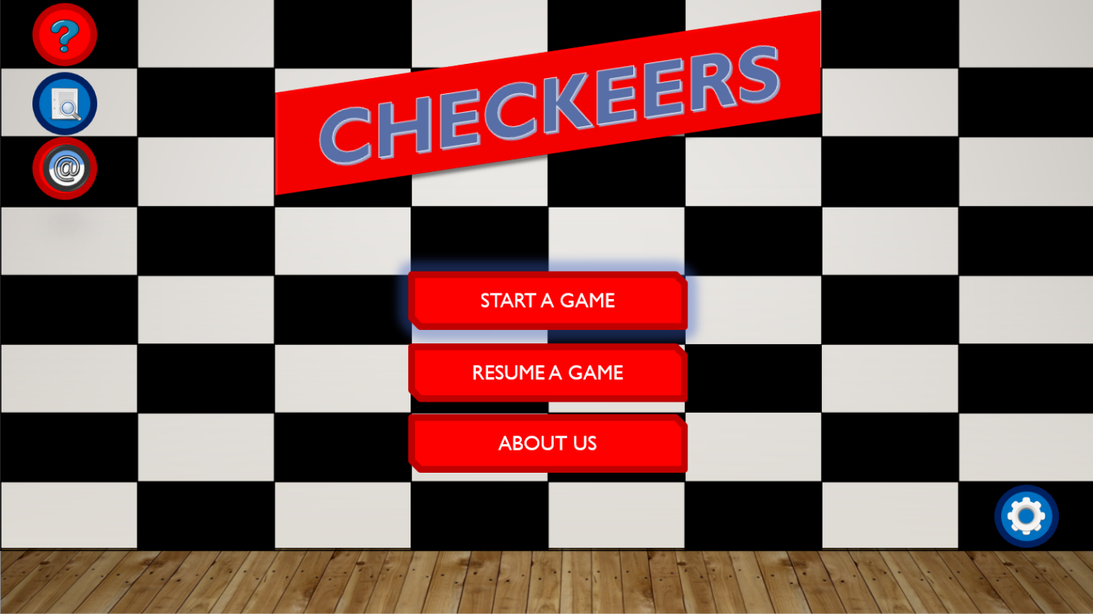

**Pointing on an icon:**

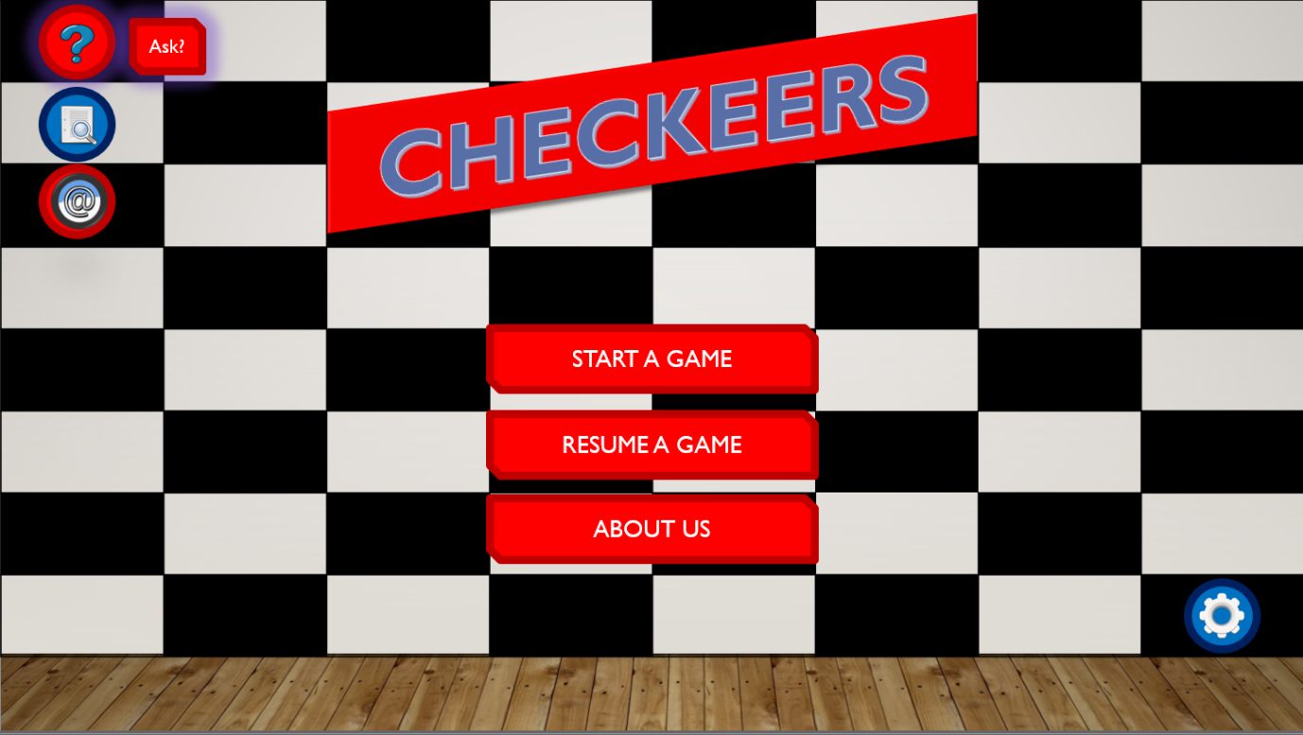

**Scenarios**

**Initial Board Look:**

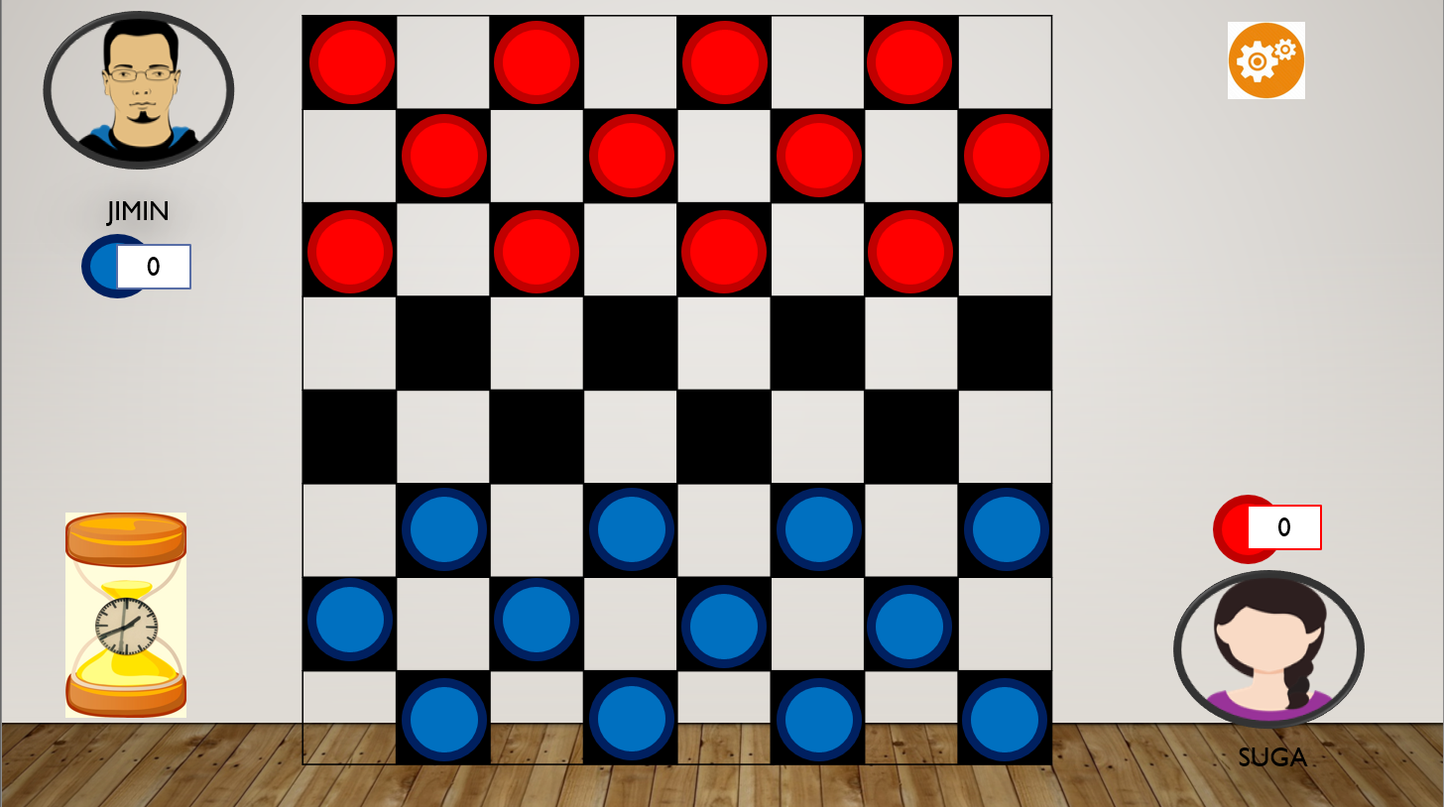

**When you point on a key:**

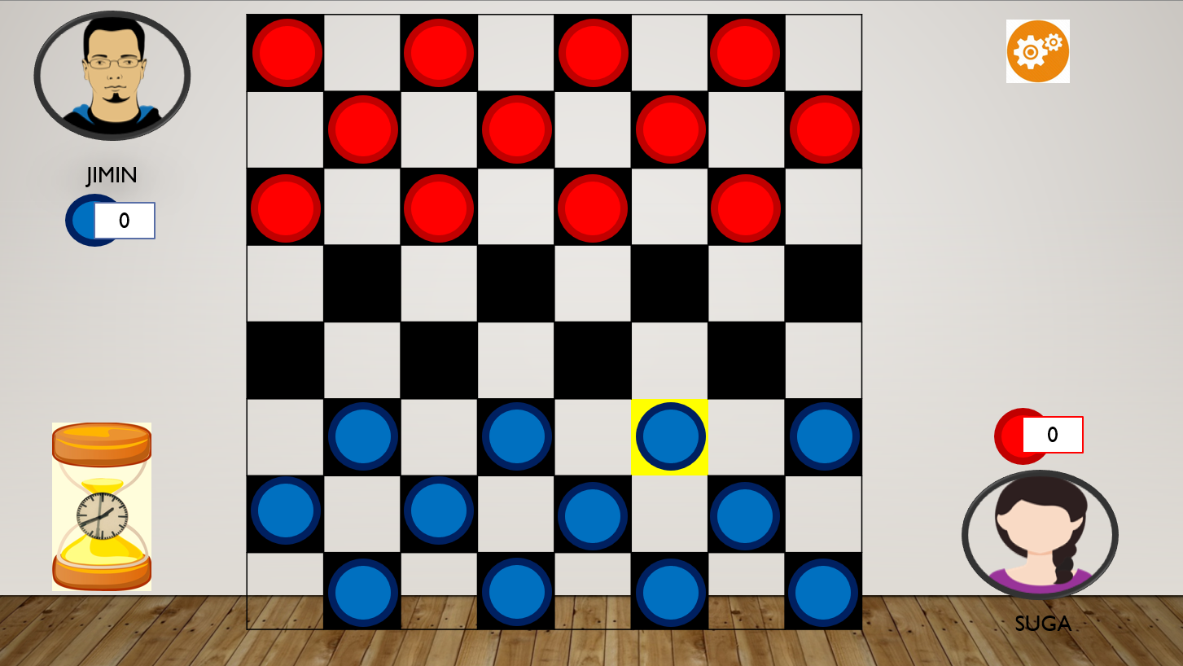

**When the player clicks on that key:**

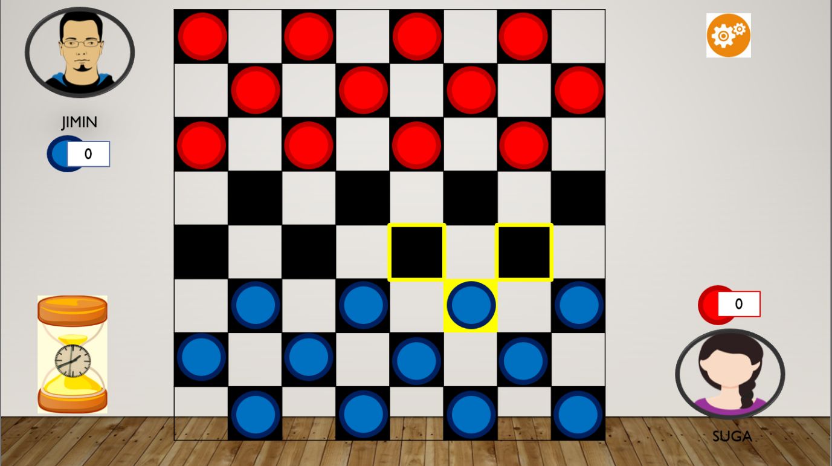

**After both of users have played a move:**

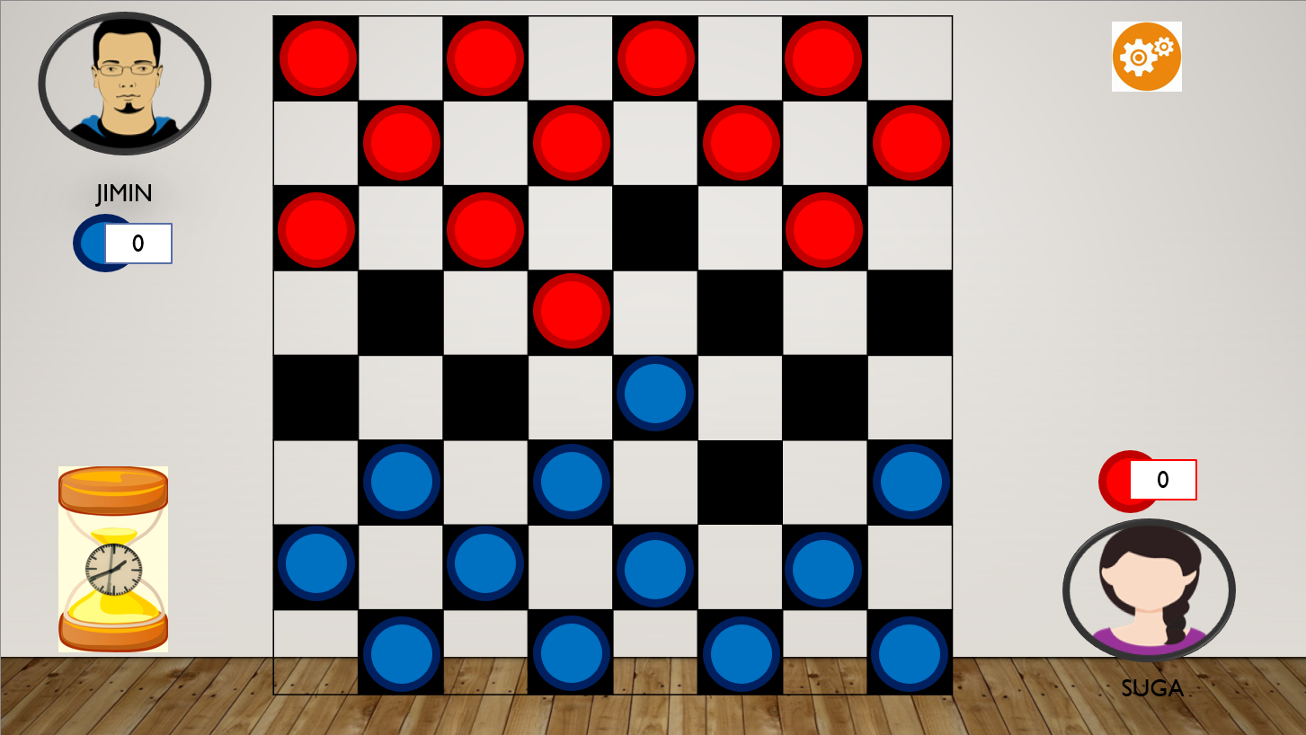

**Capturing a move:**

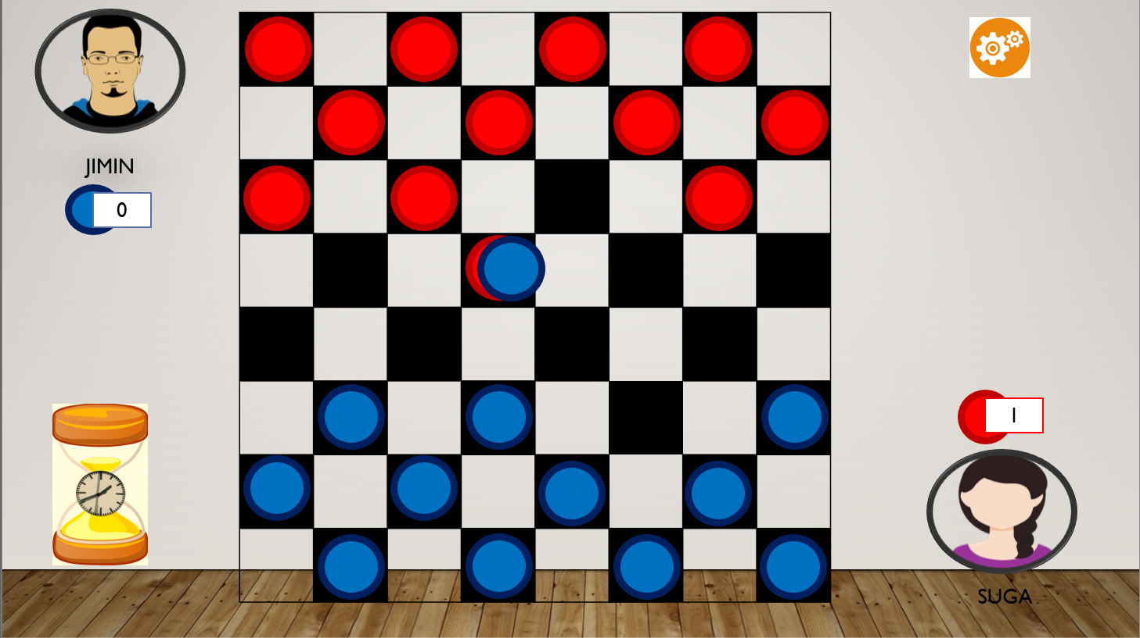

**How the score increases!**

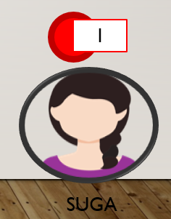

**Multiple Capturing option:**

**Case 1:** When two keys are there to capture one.

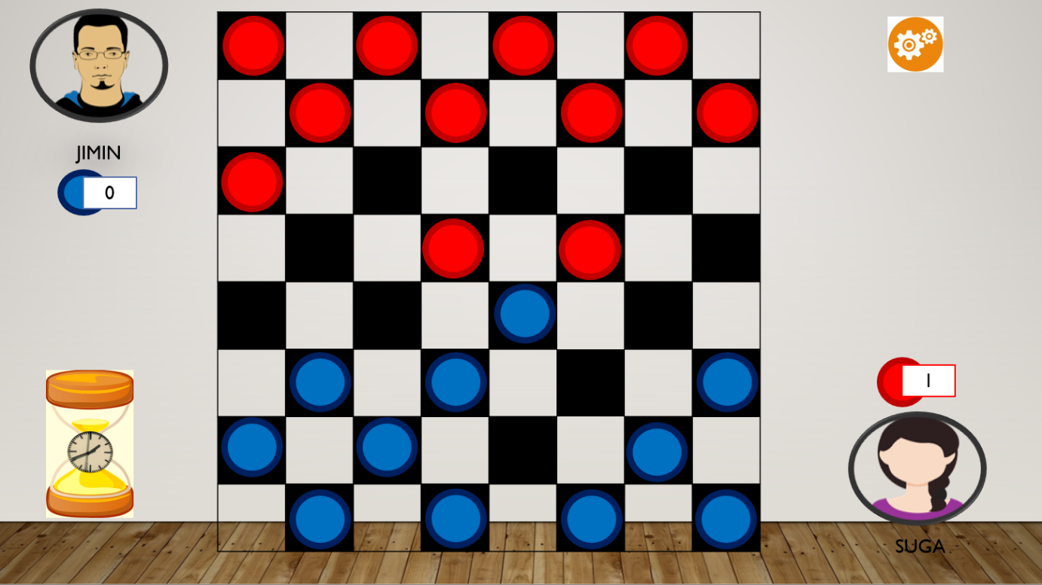

**Case 2:** When one key can capture two at same time.



**Crowning a King:**

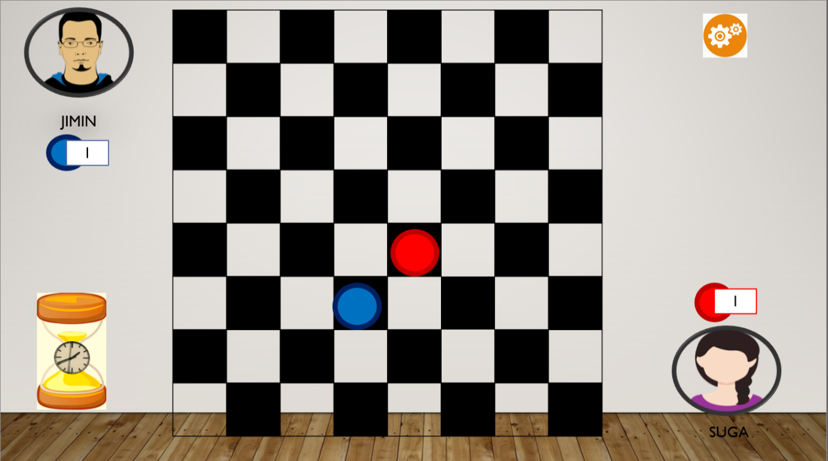

**`1**

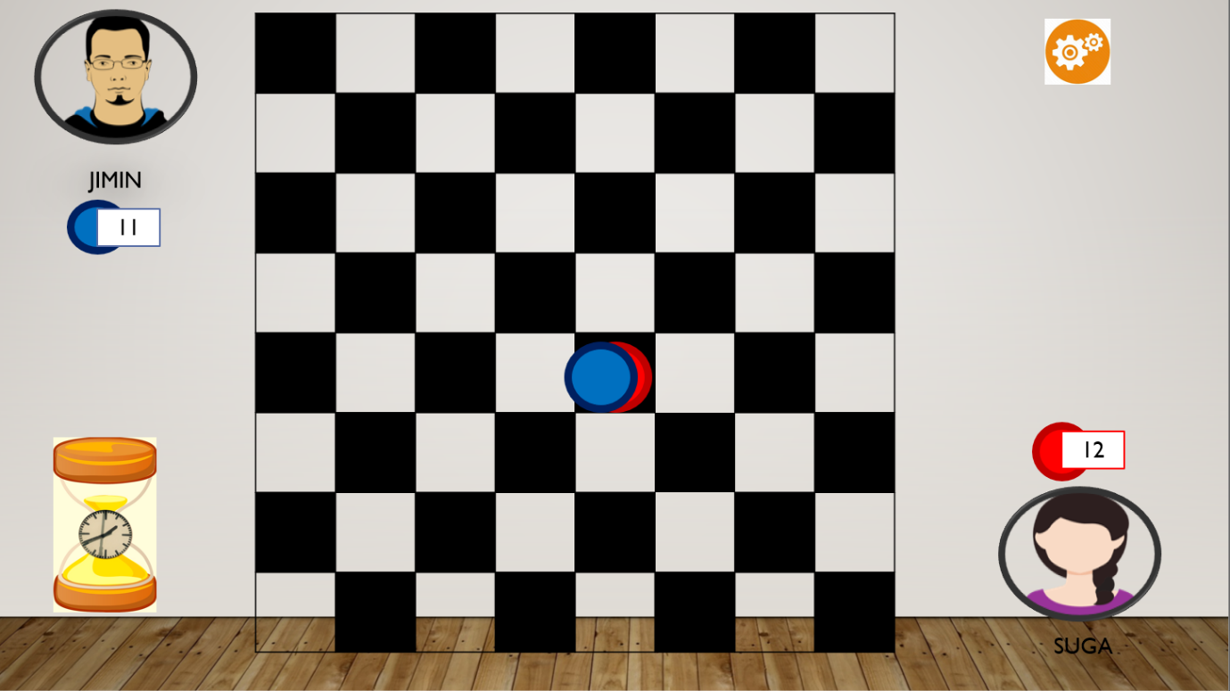

**Comparing scores**

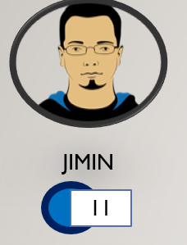 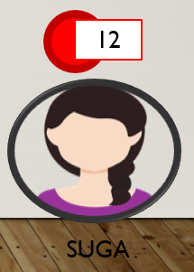

**WINNER ANNOUNCEMENT:**

